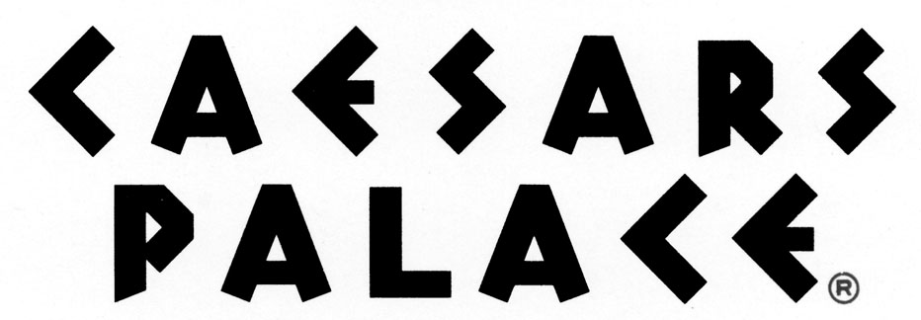

FOR IMMEDIATE RELEASE
November 16, 2012

OCTAVIUS TOWER AT CAESARS PALACE BRINGS 450 NEW JOBS TO LAS VEGAS MARKET

LAS VEGAS, Nev. – Caesars Palace has announced it will hire a total of 450 employees with the opening of Octavius Tower on January 2, 2012. The resort’s sixth hotel tower will yield 3,960 total accommodations, bringing hundreds of new jobs to the Las Vegas market.

The resort is currently seeking qualified candidates for both front- and back-of-house positions in hotel operations, guest services and VIP services. Applications are currently being accepted online at www.caesars.com/employment.

The 668-room hotel tower will offer a unique and private luxury resort experience with an exclusive entrance, attentive staff and separate hotel lobby. Spacious guest rooms will feature plush pillow top mattresses with Anichini™ linens and marble-tiled bathrooms with oversized whirlpool bathtubs, glass showers with multiple shower heads and flat screen televisions. An innovative technology package will include cutting-edge media hubs and a unique application which will allow guests direct access to guest services from the convenience of a smart phone or tablet device. Rooms are on-sale now, click here to book a room in Octavius Tower.

The opening of Octavius Tower marks a major milestone in the two-year renaissance of Caesars Palace, which began in March 2011 with the return of Celine Dion and encompasses major entertainment and dining initiatives including the return of Elton John and the premiere of Rod Stewart at The Colosseum and the opening of Central Michel Richard, by its namesake award-winning chef. Newly announced projects also include Old Homestead Steakhouse (to open winter 2011), Nobu Hotel, Restaurant and Lounge (to open fall 2012) and Shania Twain’s Colosseum headlining residency (to premiere December 2012).

About Caesars Palace:
Caesars Palace is the world’s best known resort-casino, celebrating the grandeur that was Rome in an 85-acre destination location that sets the standard for entertainment, dining and luxury. Reigning at the heart of the Las Vegas Strip, Caesars Palace features 3,960 hotel guest rooms and suites, including the addition 180-room Nobu Hotel set to open in 2012; 25 diverse restaurants and cafes, including the 24-hour café by James Beard award-winning Chef Michel Richard; nearly 129,000 square-feet of casino space; a five-acre Garden of the Gods pool complex showcasing eight pools and two wedding gardens; the 55,000 square-foot award-winning Qua Baths & Spa and Color Salon by renowned celebrity colorist Michael Boychuck; the acclaimed 683,000-square-foot Forum Shops offering more than 180 boutiques and shops; Cascata, one of the world’s most exclusive golf courses; and the 4,300-seat Colosseum spotlighting world class entertainers such as Celine Dion, Elton John, Rod Stewart, Jerry Seinfeld, and Shania Twain (beginning December 2012).

Caesars Palace, along with all Caesars Entertainment Las Vegas resorts, including Planet Hollywood Resort & Casino, Paris Las Vegas, Flamingo Las Vegas, Harrah’s, Bally’s, Rio All-Suite Hotel & Casino, Imperial Palace and Bill’s Gamblin’ Hall & Saloon, proudly prohibit adding hidden resort fees to hotel guest room rates. For information on No Resort Fees visit www.caesars.com/vegasnoresortfees. For more information call 866-227-5938 or visit www.caesarspalace.com; find Caesars Palace on Facebook and follow on Twitter.

####

Media Contacts:
Leslie Thuet
Public Relations Manager
lthuet@caesars.com
(702) 271-1809

Celena Haas
Director of Public Relations
chaas@caesars.com
(702) 794-3307

